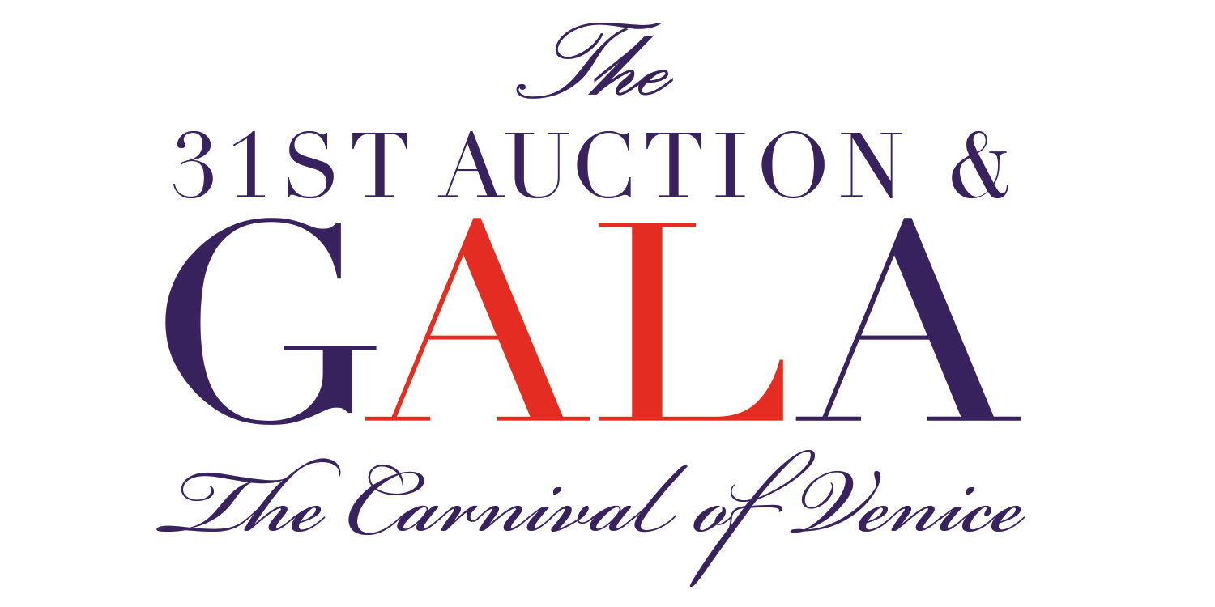
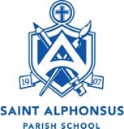

February 6, 2019
Greetings [name of business]!
I am a parent with St. Alphonsus Parish School and am writing to you on their behalf. It is with great excitement that we invite you to participate in a very special event. St. Alphonsus Parish School is hosting our 31st Annual Auction and Gala on Saturday, November 16, 2019.
St. Alphonsus has served the Ballard community of Seattle for over 100 years, offering families a quality Catholic education for preschool through 8th grade students. All proceeds from our Auction & Gala will directly benefit the students of St. Alphonsus.
We are asking you to consider making a donation of [be as specific as possible here]. We will gladly take care of all the necessary paperwork and arrange to pick up the item, if necessary, at your convenience. Our auction system will generate a receipt once your item has been entered in our database and we will acknowledge your gift in our auction catalog.
We would like to receive all items by October 4, 2019.
St. Al’s is a 501(c)3 organization and all donations are tax deductible to the full extent of the law (Tax ID#: 91-0577481).
If you have any questions, please let us know.
Thank you in advance for your support of this important event. Your contribution will make a difference!
Sincerely,
[your name]
auction@stalseattle.org

